22AIE205 – Introduction to Python

Lab Assignment 7

Name: AKEPATI SATHISH REDDY
Reg.NO: CH.SC.U4AIE25001
Department: AIE 25-29

Lab Exercise 7.1 – Tax Calculation Portal
7.1: Develop a tax calculation portal with an option for the user to select the preferred tax regime.
Requirements:
- Create a user-friendly GUI using Tkinter.
- Provide input fields for the required user details, such as annual income.
- Include an option to select the tax regime (Old Regime / New Regime).
- Calculate the income tax based on the selected regime.
- Display the calculation result clearly in the GUI.
- Arrange the widgets properly using suitable Tkinter layout managers.
- Include appropriate input validation and a reset/clear option.
Code:
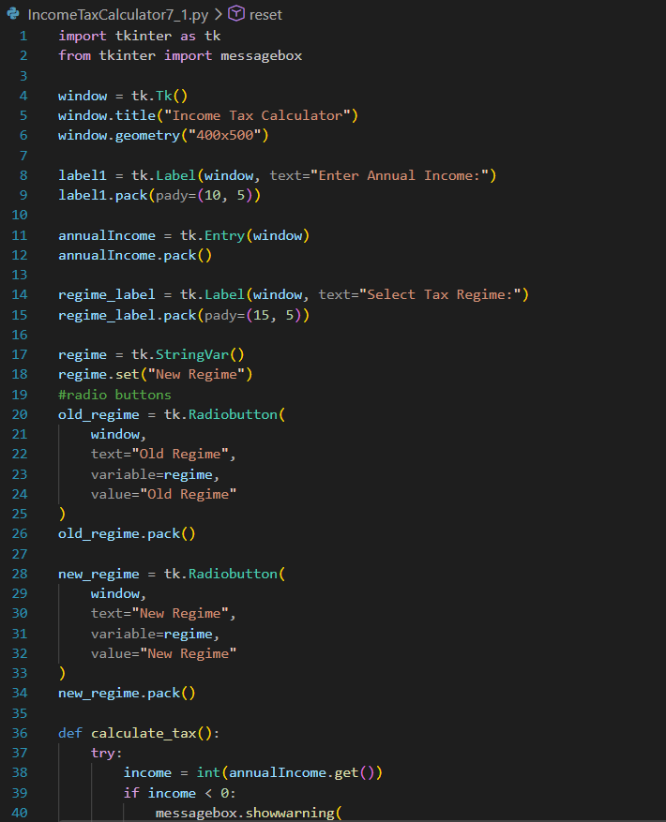
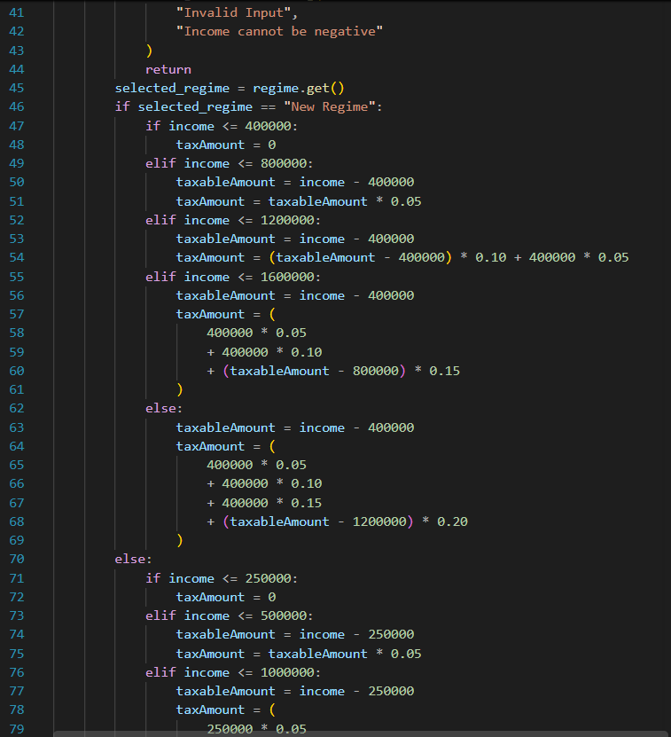
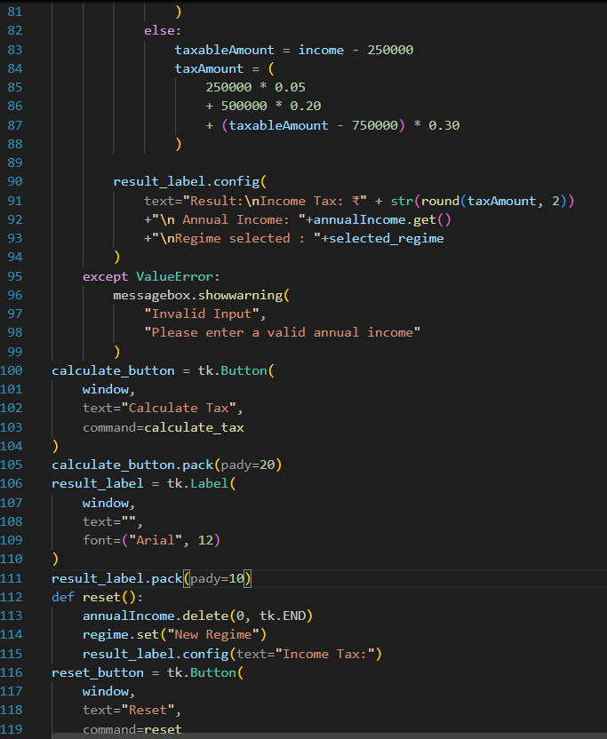

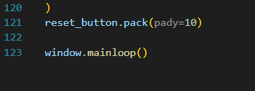
Multiple Validations
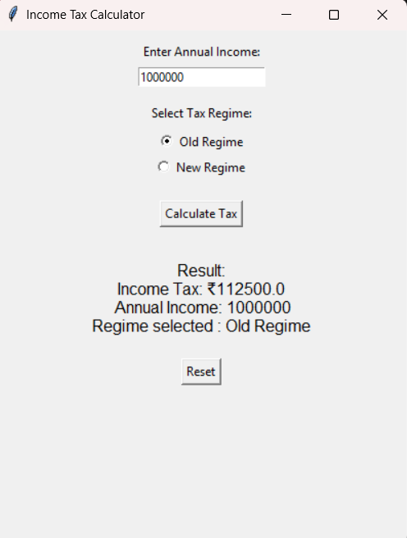
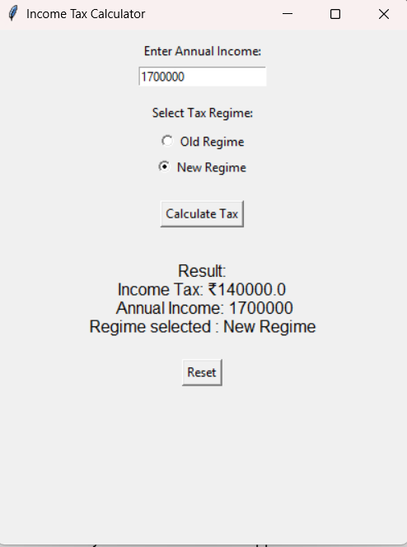:
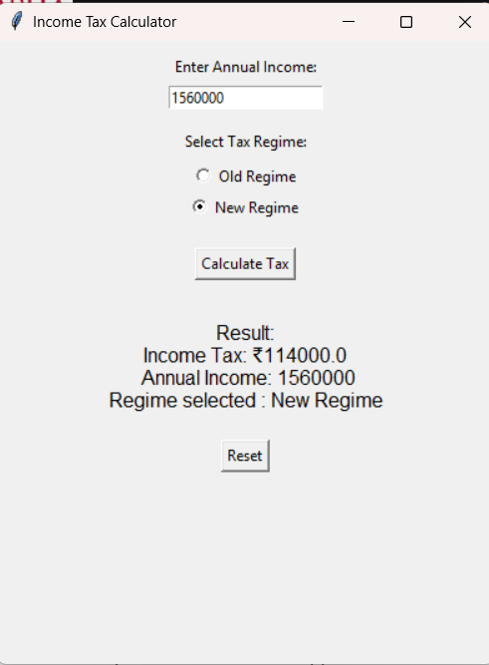

Inference:
- The Tkinter GUI successfully accepts annual income and allows the user to select the preferred tax regime.
- The program calculates income tax according to the selected tax slabs.
- Input validation prevents invalid or negative income values from being processed.
- The Reset option clears the entered data and restores the default settings.

7.2: Develop a simple calculator application using Python Tkinter.
Requirements:
- Design a calculator GUI with a suitable window layout.
- Include buttons for numbers (0–9) and arithmetic operations (+, −, ×, ÷).
- Provide a display area to show the input and result.
- Implement the basic arithmetic operations using button click events.
- Include Clear and Equals functionality.
- Arrange the widgets properly to create a neat and user-friendly design.
- Handle invalid operations, such as division by zero.

Code:
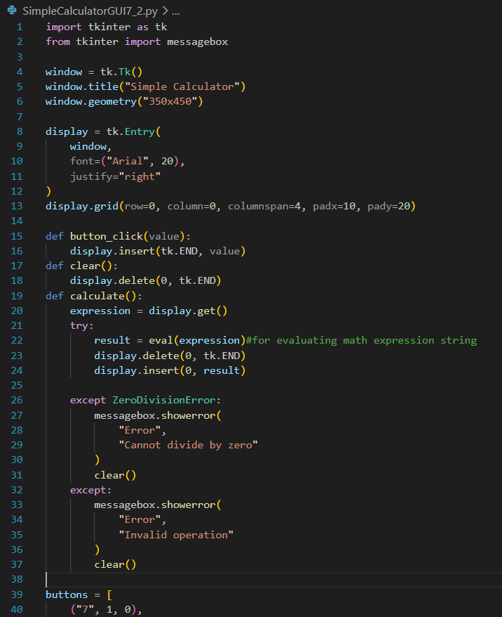
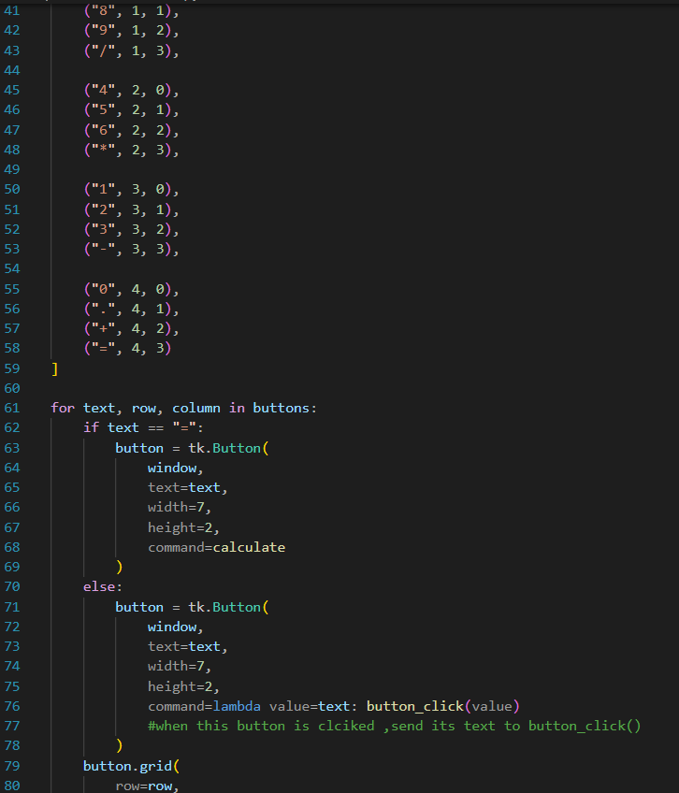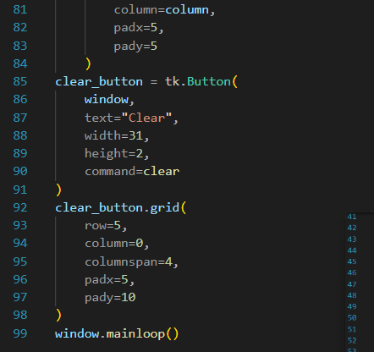

Multiple Validations:
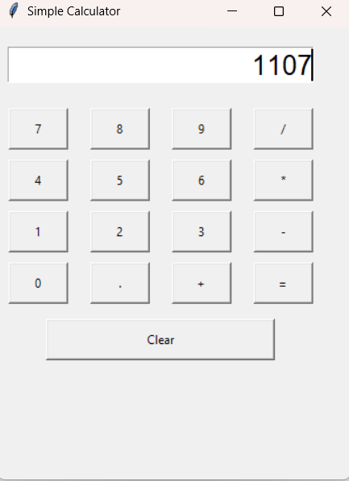
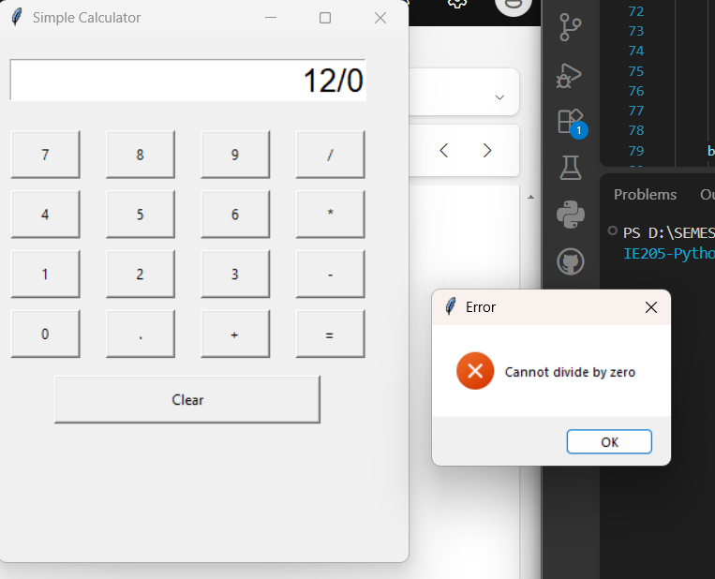
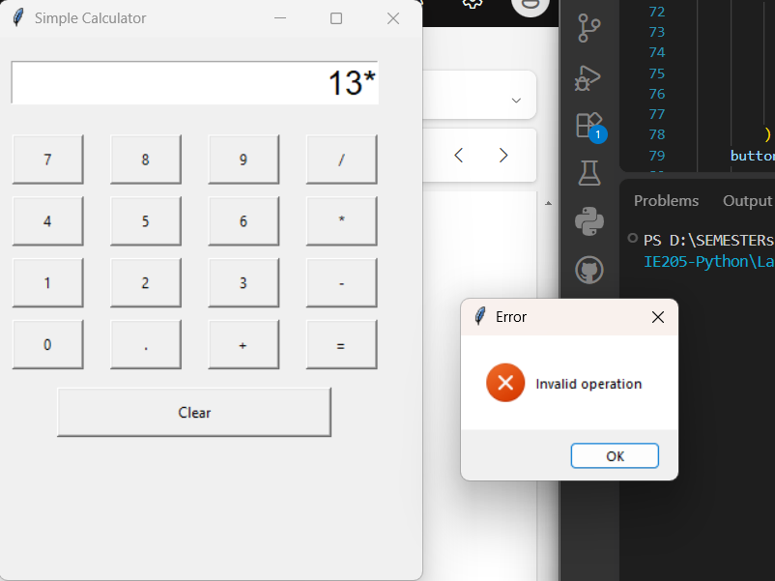

Inference:
- The Tkinter calculator successfully performs basic arithmetic operations such as addition, subtraction, multiplication, and division.
- The grid() layout manager organizes the calculator buttons in a structured row-and-column format.
- Exception handling successfully manages invalid operations such as division by zero.
- The Clear and Equals buttons allow the user to control the calculation and display the result.

